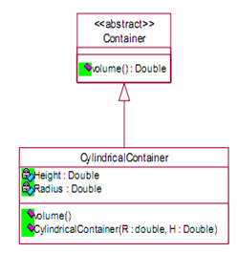

# Question 01

The Volume of a Cylinder can be found with the following formula:

Volume = PI * Radius*Radius*Height where PI=3.14159

It is required to map the above class diagram to Java code.

Note: Container is an abstract class.

Height & Radius are private variables

All the methods are public

1. Write down the Java definition of class container

public abstract class Container {  
 public abstract String volume();

}

1. Write the Java Definition of class CylindricalContainer. (Implement the Methods)

public class CylindricalContainer extends Container {  
 private double height;  
 private double radius;  
   
 public CylindricalContainer(double height, double radius){  
 this.height = height;  
 this.radius = radius;  
 }

@Override  
 public String volume(){  
 double volume = Math.*PI*\*radius*radius*height;  
 String result = String.*format*("%.2f", volume);  
 return result;  
 }  
   
}

1. Create an object from CylindricalContainer and display the volume.

public class CylinderVolume {  
  
 public static void main(String[] args) {  
 var cylinder1 = new CylindricalContainer(7F,5F);  
 System.*out*.println("Volume: "+cylinder1.volume());  
 }  
}

# Question 02

A Student wants to create a game called “Life”, ‘life’ is a RPG game in which a player can move up, down, left & Right. In order to implement this game assume that you need to create an abstraction of the player controllers. Make sure to print the directions of the player when keys are pressed.